Layers of the Earth Webquest Name _________________________ Hr____
**Explore the following websites and answer the corresponding questions below to help you figure out what is so special about the structure of our Earth!**
Part I. The Layers of Earth :
- Structure of the Earth: http://volcano.oregonstate.edu/earths-layers-lesson-1
- Label the layers of the Earth
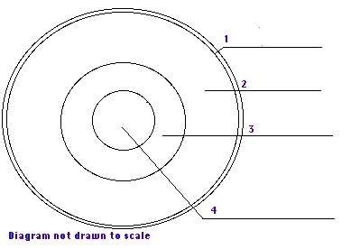

- What causes the mantle to “flow”? ________________________________________

- What are the two main metals that make up the Earth’s core? ___________________________ and _____________________________

- Describe, in your own words, how the earth’s layers were formed? (see “The Four Layers”)
____________________________________________________________

____________________________________________________________

- The Crust and Lithosphere (Earth’s Crust & the uppermost part of the Earth’s Mantle):
Use the following sites to help you understand the Crust and Lithosphere--https://web.archive.org/web/20160121223454/http://www.mnh.si.edu/earth/text/index.html(click on “Plate Tectonics “Inner Earth”, read the Introduction (2 slides/pages) and then click on CRUST, MANTLE (info on Lithosphere here!), and CORE) &
http://www.harcourtschool.com/activity/science_up_close/606/deploy/interface.html
- What is special about the Lithosphere? ______________________________________________________________ ______________________________________________________________
- Complete the following table:
Types of Crust
Oceanic | Continental
Thickness: | Thickness:
Made of: | Made of:
VIP #1: | VIP #1
VIP #2: | VIP #2:

- Tectonic Plates: https://web.archive.org/web/20160310144919/http://www.sciencemonster.com/earth-science/layers-of-the-earth.html–only use the first 3 pages!!!

- What are tectonic plates? __________________________________________________________
- What is something else that you learned from pages 1-3 that helps you understand what is special about the Earth’s structure? __________________________________________________________

__________________________________________________________

Part II. Convection Currents and the Mantle

Heat transfer is the movement of heat energy from a warmer object/place to a colder object/place. There are three ways in which heat can be transferred: radiation, conduction, and convection. Click on the following links and discover the awesomeness of what heat transfer can (& does) do for YOU!
- Go to https://www.wisc-online.com/learn/natural-science/earth-science/sce304/heat-transfer--conduction--convection--radiation , Convection, Conduction and Radiation and Heat Transfer websites.

- How is heat transferred by conduction? __________________________________________________________ ____________________________________________________________
- Explain the process of convection. __________________________________________________________

__________________________________________________________

- How is heat transferred by radiation? ______________________________________________________

__________________________________________________________

- On the Heat Transfer web page, click here and take the “Mini Quiz”. Put your answers below.

- _____ 2. _____ 3. _____

- Go to www.universetoday.com/26717/earths-mantle/ to learn about what influence convection currents have on Earth. Read and answer the following questions.

- Describe how convection currents occur in Earth’s mantle. __________________________________________________________

__________________________________________________________

- What is a constructive force caused by the convection in the mantle? __________________________________________________________

__________________________________________________________

- What is a destructive force caused by the convection in the mantle? __________________________________________________________

__________________________________________________________

