How Are Minerals Formed?
By Max Roman Dilthey; Updated April 24, 2017
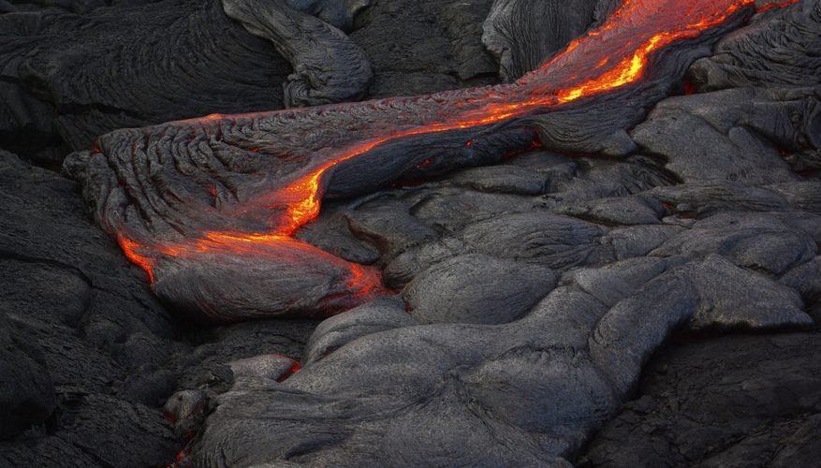
Minerals are naturally occurring chemical compounds that have a solid, crystalline structure, meaning they're arranged in unique geometric patterns at the atomic level. Minerals are also inorganic; they're not formed from amino acids, peptides, or enzymes, as living things are. Minerals make up rocks, but are homogeneous by nature, meaning each mineral is unique and pure in structure. A mineral can be formed under a variety of conditions, including the cooling of lava or liquid solutions, the evaporation of mineral-rich water, and at high temperatures and pressures found in the core of the earth.

WHAT'S IN A MINERAL?
As a pure, inorganic crystalline solid, a mineral has a uniform structure at the molecular level. A man-made substance with a pure structure is not a mineral; only solids that occur naturally are considered true minerals. Minerals grouped together form rocks; the combination of minerals determines the type of rock formed. Since minerals are pure, they can all be written as a single chemical formula. A mineral can also contain some impurities and still retain its name, as long as the majority of the solid is a single mineral. There are over 3,000 known minerals, and the list is still growing.

FRESH FROM THE OVEN
Minerals can be formed from the intense heat and pressure found far beneath the earth's crust in the mantle, where molten rock flows as liquid magma. Silicates in the magma can form minerals such as hornblende and other igneous rocks as the magma cools. This process can take millions of years. Ninety-five percent of the earth's crust is formed from nine minerals, all of which are silicates, formed in this manner. Oxygen and silica, the most abundant mineral-forming elements in the earth's mantle, form silicates in a wide range of temperatures and conditions.

EXTRUSIVE AND INTRUSIVE ROCK
All rocks are formed from a combination of minerals. You can identify a rock's type, along with characteristics that contributed to its formation, from its mineral composition. Minerals provide a basic reference for geologists to study the earth's crust and are separated into categories based on their mineral composition and structure. Extrusive rocks are formed from minerals that crystallized quickly as magma cooled outside Earth's crust, forming smaller crystals. Intrusive rocks cool slowly beneath the crust, allowing for much larger crystal structures to form over time.

LIQUID MINERALS
A solid mineral deposit can also be formed from the evaporation of a liquid solution. When a mineral is suspended in a solution, it can collect as the water in the solution evaporates into the air. Examples of mineral deposits formed this way can be found in caves; calcite-saturated groundwater can slowly collect in stalactites and stalagmites over time. Minerals such as salt and gypsum, called evaporites, usually form at high temperatures from the evaporation of seawater.

Checking for Understanding
- Minerals are grouped together to form ____________________.
- How many known minerals are there?

- The earth’s crust consists 95% of _____________________.
- Create a Venn Diagram to distinguish the difference between Intrusive and Extrusive rocks.

- Describe the formation of minerals in two ways.

