FORCES Study Guide:
- What is friction?

- How does friction affects motion?

- Circle the positions gravity affects the ball below.

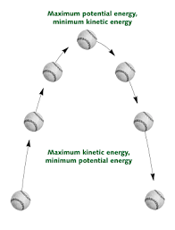

- What is a balance force and give 2 examples?

- What is an unbalance force and give 2 examples?

- True/False? If an object is in motion and more force is applied, it will move slower.__________
- True/False? A force can act to cause an object at rest to move or it can accelerate an object that is already moving. ___________
- True/False: Balanced forces acting on an object never changes the object’s motion. ____________

- How can a force change the motion of an object that is already moving?

- A worker on the Earth and an astronaut on the Moon are each holding a hammer. If they let go of their hammers at the same time, which person’s hammer will hit the ground first? Why?

- An object is moving at a constant speed. If a balanced force is applied in the opposite direction the object is moving, what will most likely happen?

- When workers spread sand over icy bridges and roads in the winter, how does this help people drive on the roads?

- An object is pulled northward with a force of 10 N and southward with a force of 15 N.
What is the net force on the object? ___________________________________

- During tug of war Janelle felt she was supergirl and attempted to beat Rameek. Janelle with one arm on the rope and the other at her side applied a 100 N force to the left, while Rameek applied a 100 N force with both hands to the right. What is the net force and direction on the rope?

- Janelle finally decided to take this seriously and put both hands on the rope and applied a 150 N force to the left, while Rameek still struggled with his 100 N force to the right. What is the net force and direction of motion?

- When unbalanced forces act on an object at rest, the object will _____________.
- Forces that are equal in size but opposite in direction are called ______________ forces.
20. Forces that cause a change in the motion of an object are _____________ forces.
- If a marble and baseball is rolled across a table using the same force, which ball will roll the fastest and why?

22. Below is a diagram of a tug-a0war. Circle the correct word to complete the sentences that follow.
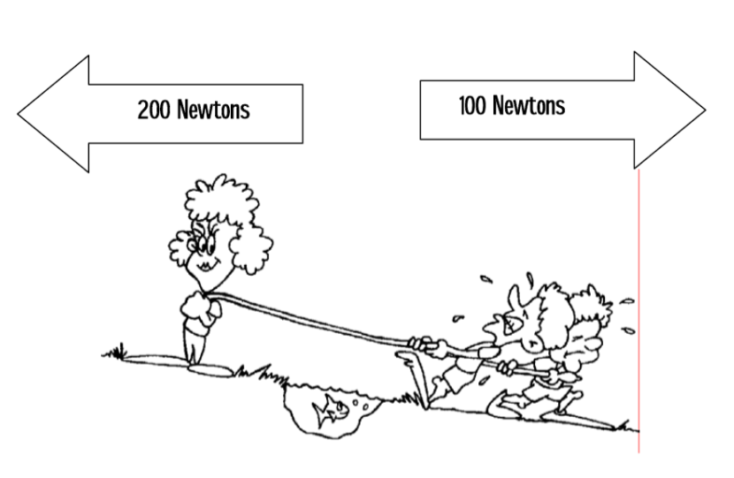
a. The forces shown are PUSHING/ PULLING forces.
b. The forces shown are acting in the SAME DIRECTION/ OPPOSITE DIRECTIONS.
c. The forces are EQUAL/ NOT EQUAL.
d. The forces are BALANCED/ UNBALANCED..
e. Motion is to the RIGHT/ LEFT.
f. What is the net force?

23. Draw an example of an unbalanced force. Don’t forget to label how many Newtons of force are being used in each direction. (3 points)

